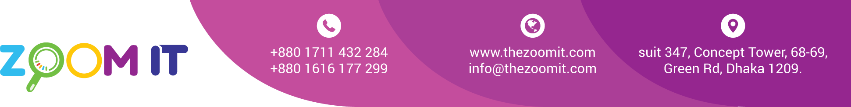

**Bill**

|  |  |
| --- | --- |
| Date | 14/11/2022 |
| INV. NO. | 10141 |

|  |  |
| --- | --- |
| Name | **ITS Holydays Ltd** |
| Address | House-150, Block-E, Road-10, Banani, Dhaka. |

|  |  |  |  |
| --- | --- | --- | --- |
| **Sl.**  **No.** | **Description** | **task** | **Value in Taka** |
| 1  2 | Website Development  Old Due |  | 15,000  10,000 |
|  | | Total | 25,000 |
| Paid |  |
| Due |  |

BANK Details

Ac Name: ZOOM DIGITAL AC NO: 2228119002279

Prime bank Racecourse Branch

Signature